

VIERNULVIER ARCHIVE
USER MANUAL
Public archive website and administrator CMS

AUTHORS
Name | Role
Prince-Bert Beya | Backend Manager
Jasper Delmeiren | System Administrator
Noah Delvoye | Frontend Manager
Tobit De Smet | Group Leader
Arne Maegherman | Customer Relations Officer
Florian Mataigne | Test Manager
Elias Ryckaert | Technical Lead

REVISION HISTORY
Version | Date | Description
1.0 | May 16th, 2026 | User manual for final milestone.

DOCUMENT INFORMATION
This user manual explains how visitors and staff members can use the VIERNULVIER Archive web application and its administrator interface. It is written for non-technical users and focuses on navigation, searching, filtering, viewing content and basic CMS management tasks.

TABLE OF CONTENTS
1. INTRODUCTION 1
1.1 Audience 1
1.2 Scope 1
2. PUBLIC ARCHIVE WEBSITE 1
2.1 Main areas 1
2.2 Navigation and general controls 1
2.2.1 Header navigation 1
2.2.2 Footer 2
2.3 Searching, sorting, filtering and pagination 2
2.3.1 Search 2
2.3.2 Sorting 2
2.3.3 Filters 2
2.3.4 Grid and list views 3
2.4 Using the public pages 3
2.4.1 Home page 3
2.4.2 Archive / Productions page 3
2.4.3 Production detail page 3
2.4.4 Series overview 4
2.4.5 Series detail page 4
2.4.6 Blogs overview 5
2.4.7 Blog detail page 5
2.4.8 Media page 6
3. ADMINISTRATOR CMS 7
3.1 Logging in 7
3.2 Dashboard 7
3.3 Admin list pages 8
3.4 Managing records in the admin panel 8
3.4.1 Adding a new record 8
3.4.2 Editing a record 9
3.4.3 Deleting a single record 9
3.4.4 Bulk actions and bulk deletion 9
3.4.5 Searching, filtering and sorting records 10
3.4.6 General recommendations 10
3.5 Users and groups 10
4. API DOCUMENTATION 10
5. TROUBLESHOOTING AND GOOD PRACTICES 11
5.1 Public website issues 11
5.2 CMS issues 11
5.3 Content editing recommendations 11

INTRODUCTION
The VIERNULVIER Archive is a web application for browsing productions, series, editorial blog posts and media files related to Kunstencentrum VIERNULVIER. The public website is intended for visitors who want to explore the archive, while the administrator CMS is intended for staff members who maintain the archive content.

1.1 Audience
- Public visitors who want to search, browse and read archive content.
- Archive editors who manage productions, blogs, media files and related metadata through the CMS.
- Administrators who manage users, groups and permissions in the Django admin interface.

1.2 Scope
This manual covers the user-facing archive website and the main CMS workflows visible in the screenshots: logging in, using the dashboard, browsing admin tables, adding productions and editing existing productions. It does not replace the technical installation guide.

PUBLIC ARCHIVE WEBSITE

2.1 Main areas
- Home gives an entry point to the archive with a global search field, quick links and high-level statistics.
- Archive lists productions and lets users search, filter, sort and switch between grid and list views.
- Series groups related productions into recurring series or themed collections.
- Blogs contains editorial stories and background articles.
- Media contains uploaded files such as images and PDF documents.

2.2 Navigation and general controls

2.2.1 Header navigation
The navigation bar is available at the top of the website. It contains links to Home, Archive, Series, Blogs and Media. The active page is underlined so users can see where they are.
- Click a navigation item to move to another part of the archive.
- Use the moon or sun icon to switch between dark and light appearance, when available.
- Use the language toggle to switch between Dutch and English versions of the interface.

2.2.2 Footer
The footer contains VIERNULVIER contact details, navigation links, social media icons and a newsletter call-to-action. It appears at the bottom of collection pages and can be used as an alternative navigation area.

2.3 Searching, sorting, filtering and pagination
Most collection pages share the same interaction pattern: a search bar, sorting controls, sort direction button, a grid/list view switch and a result counter. The Archive page also includes a filter panel for date, genres, tags, performer type and attendance mode.
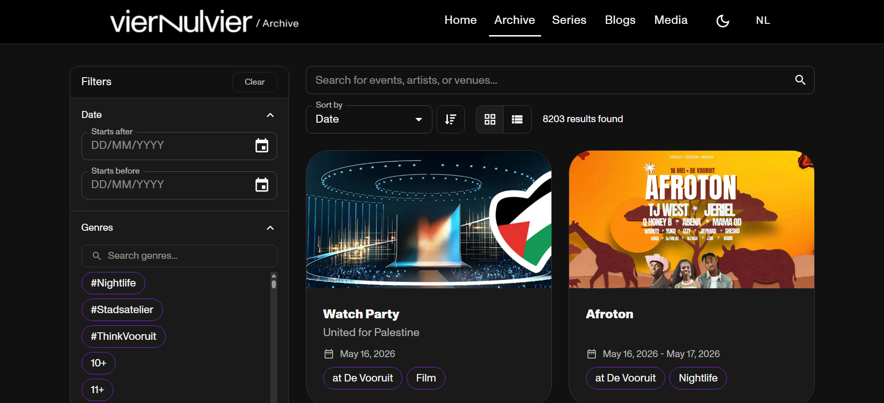
Figure 1: Archive page with filter panel, search bar, sorting controls, view toggle and production cards

2.3.1 Search
- Click inside the search field.
- Type a keyword such as an event name, artist, location, blog title or media filename.
- Confirm the search by pressing Enter or by using the search icon/button, depending on the page.
- Review the updated result count and the displayed cards.

2.3.2 Sorting
Use the Sort by dropdown to change the order of results. Depending on the page, common options include Date and Name. The direction button switches between ascending and descending order.

2.3.3 Filters
The Archive page contains a left-side filter panel. Date filters narrow results by start date. Genre and tag filters help users discover productions that match one or more categories.
Additional filters may also be available for performer type and attendance mode.
- Use Start after and Start before to limit productions by date.
- Use the genre or tag search field to find a specific category quickly.
- Click genre or tag chips/checkboxes to include them in the filter.
- Use Performer type to filter productions by the type of performer, for example group or solo.
- Use Attendance mode to filter productions by how the audience attends, for example offline or online.
- Use Clear to reset filters when results become too narrow.

2.3.4 Grid and list views
Collection pages can display items as visual cards or compact list rows. The grid view is useful for browsing visually. The list view is useful when users want to scan many results quickly.

2.4 Using the public pages

2.4.1 Home page
The Home page provides a starting point for visitors. The hero search lets users look for events, artists or locations. The statistics block gives a quick overview of the size of the archive. The discovery cards link to the main archive sections.
- Open the public website.
- Use the hero search field to search directly, or click Open archive to browse all productions.
- Use the discovery cards to jump to Archive, Series, Blogs or Media.

2.4.2 Archive / Productions page
The Archive page is the main place to browse productions. Each card shows a production image, title, subtitle or description, date information and category chips. Click a card to open the detailed production page.
- Use filters when you know the period, genre, tag, performer type or attendance mode you are looking for.
- Use search when you know part of a title, artist name or location.
- Use sorting to move newer, older or alphabetically relevant results to the top.

2.4.3 Production detail page
The production detail page presents one production in more detail. It can include the title, subtitle, description, dates, tags, genres, locations, related events, media, related productions and related blogs. Use breadcrumbs near the top to return to the archive or previous category page.

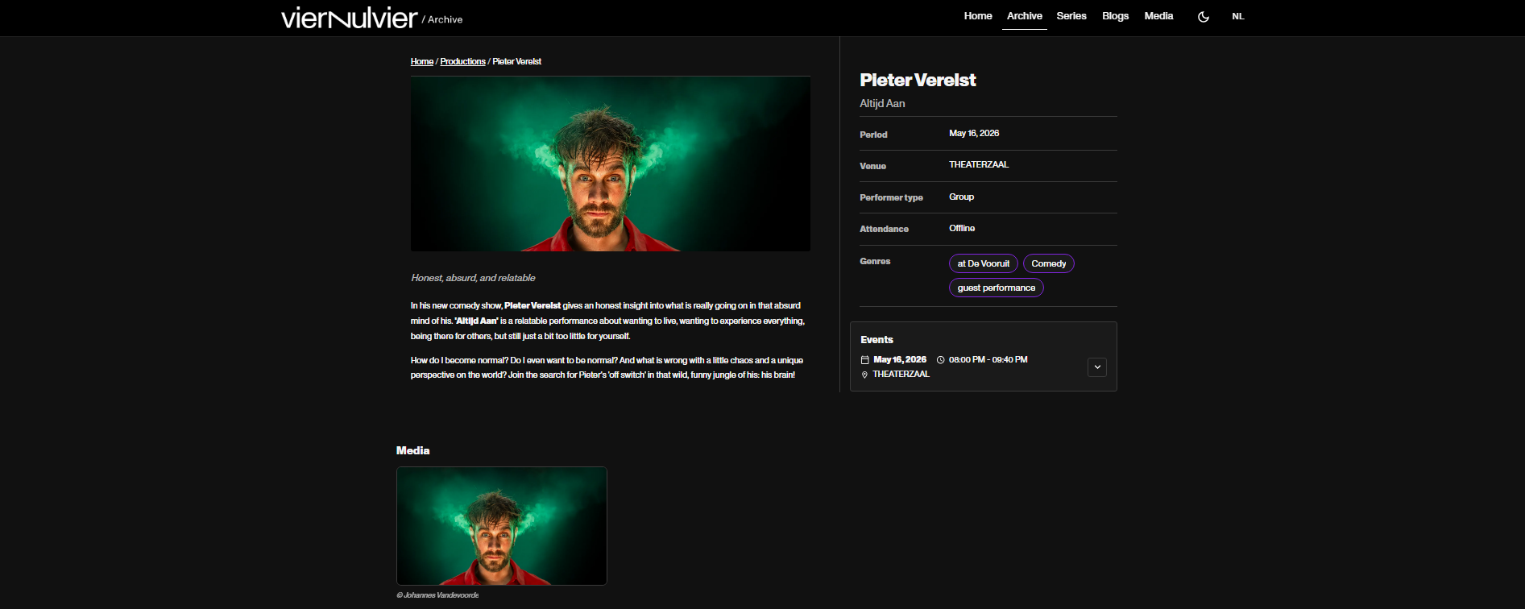
Figure 2: Example of a production detail page

2.4.4 Series overview
The Series page lists recurring series and themed collections. Users can search for a series, sort results and switch between grid and list views. Click a series card to open the series detail page.
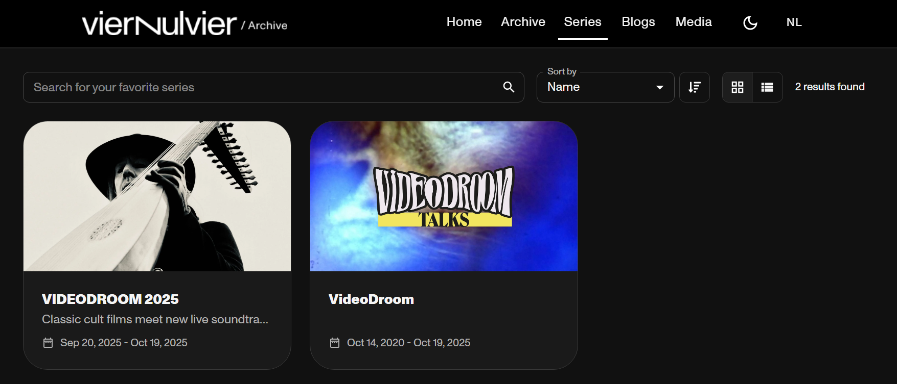
Figure 3: Series page

2.4.5 Series detail page
A series detail page explains the selected series and shows statistics such as number of editions, period and type. Below the header, productions are grouped chronologically by year so users can explore the full history of the series.
- Open the Series page.
- Search for or select a series card.
- Read the series summary and statistics.
- Scroll to All editions to browse productions in chronological order.
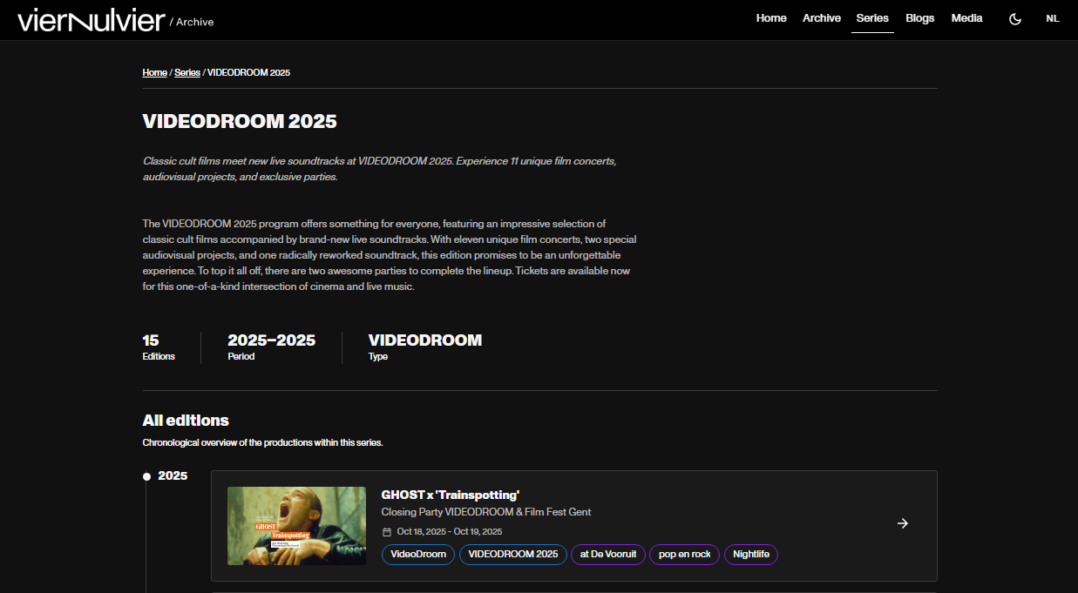
Figure 4: Example of a series detail page

2.4.6 Blogs overview
The Blogs page lists editorial posts. Cards show a cover image, title, excerpt and publication date. Search can be used to find blog posts by title or summary.
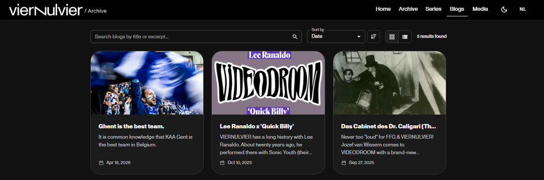
Figure 5: Blogs page

2.4.7 Blog detail page
The blog detail page displays a single article. It includes breadcrumbs, the publication date, a cover image, the title, the article content and the related productions. Use the browser back button or breadcrumbs to return to the blog overview.
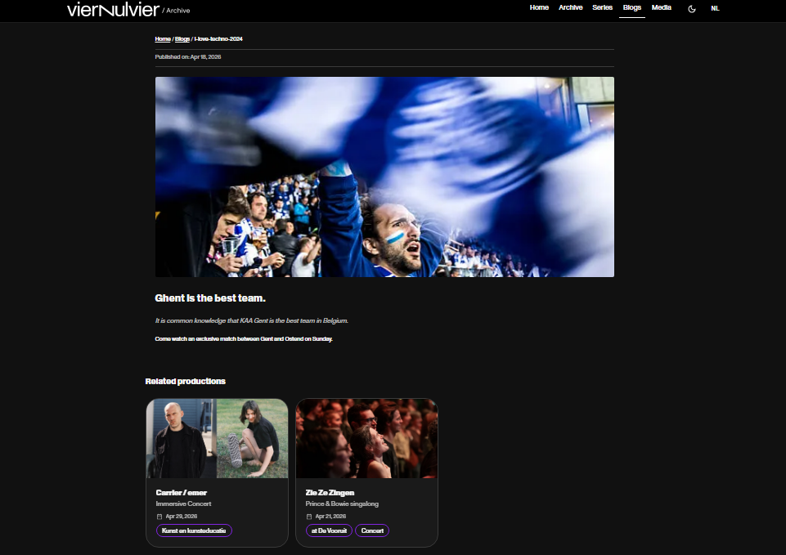
Figure 6: Example of a blog detail page

2.4.8 Media page
The Media page lists uploaded files. A media card can represent an image or a PDF. Cards show a preview, filename, description, date and file size. Click a media item to open and/or download it, depending on the browser and file type.
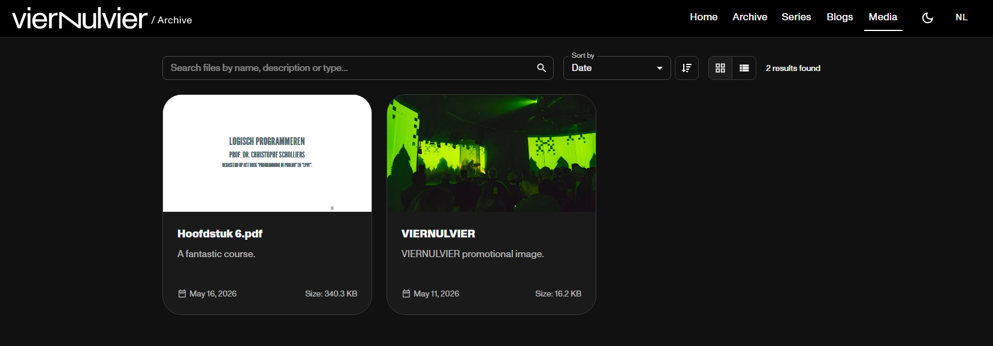
Figure 7: Media page

ADMINISTRATOR CMS
The administrator CMS is based on Django administration. It is used by authorized staff to manage archive content. Only users with a staff account and the required permissions should access this area.
Important
Changes made in the CMS can affect what visitors see on the public archive website. Always review content carefully before saving.

3.1 Logging in
- Open the admin login page.
- Enter your staff username.
- Enter your password.
- Click Log in.
If the login fails, check whether the username and password are correct and whether the account has staff access.
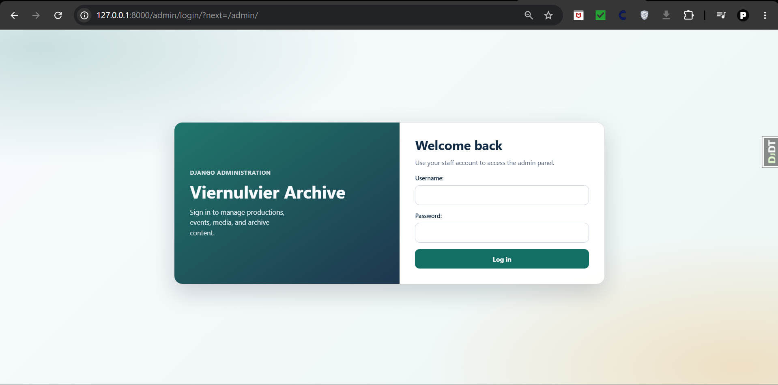
Figure 8: Custom administrator login page

3.2 Dashboard
After logging in, the dashboard gives quick access to important data tables such as Productions, Events, Blogs, Tags and Media Files. The right side shows recent changes, which helps staff review recent content activity.
- Click a dashboard card to open the corresponding table.
- Click a plus icon to add a new item for that module when you have permission.
- Use Recent changes to inspect recently added, changed or deleted records.

3.3 Admin list pages
Admin list pages show records in a table. They usually contain a search box, filters, selectable rows, action dropdowns and an Add button. Use these pages to find existing items before creating duplicates.
- Use Search to find records by visible searchable fields.
- Use the filters on the right to narrow the table.
- Click a row or linked ID/title to edit an existing record.
- Use the Add button in the top-right corner to create a new record.
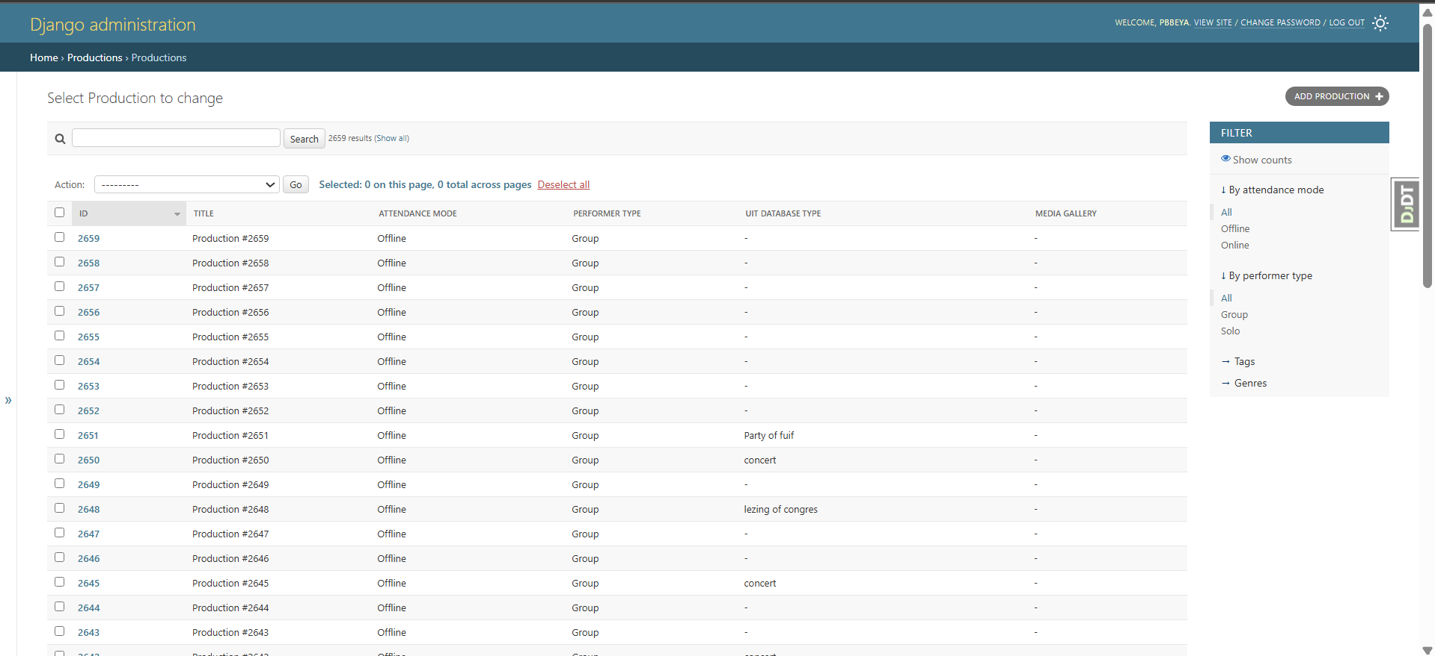
Figure 9: Example of a list page (productions)

3.4 Managing records in the admin panel
The admin panel allows authorized staff members to manage the data used by the archive website. Most content types, such as productions, events, blogs, tags, genres, locations and media files, follow the same general workflow. This means that adding, editing and deleting records works in a similar way across the different admin sections. Some list pages also provide bulk actions. For example, productions can be updated in bulk by adding selected tags or genres through the Action dropdown, in the same way that selected records can be deleted in bulk.

3.4.1 Adding a new record
To add a new record, first open the relevant section from the admin dashboard. For example, choose Productions, Events, Blog Posts or Media Files, depending on the type of content you want to create.
On the overview page, click the Add [record type] button in the top-right corner. This opens a form where the details of the new record can be entered. Fill in the required fields and, if needed, complete any optional fields or expandable sections further down the page.
Some fields use dropdowns to link the new record to existing data. For example, an event can be linked to a production and a hall. When available, the icons next to these fields can be used to add, edit or view related records without leaving the form.
After completing the form, use one of the save buttons at the bottom of the page:
- Save saves the record and returns to the overview.
- Save and add another saves the record and immediately opens a new empty form.
- Save and continue editing saves the record and keeps the current form open.
If required fields are missing or invalid values are entered, the admin panel will show validation errors. Correct the highlighted fields and save again.

3.4.2 Editing a record
To edit an existing record, open the relevant admin section and select the record from the list. You can use the search bar, filters, date hierarchy, column sorting or pagination to find the record more quickly.
Clicking the record opens the edit form. This form is similar to the add form, but it already contains the existing data. Make the necessary changes and then save the record using one of the save buttons at the bottom of the page.
For some records, a History button is available in the top-right corner. This can be used to inspect previous changes to the record.

3.4.3 Deleting a single record
To delete a single record, open the record’s edit page. At the bottom of the page, click the Delete button. The admin panel will usually show a confirmation page before permanently deleting the record.
Carefully check the confirmation page before continuing. Some records may be linked to other records, and deleting them can affect related content. Only confirm the deletion if you are sure the record is no longer needed.

3.4.4 Bulk actions and bulk deletion
Bulk actions can be used to apply the same operation to multiple records from an overview page. First, open the relevant admin section and select the records you want to update by checking the boxes on the left side of the table. Then open the Action dropdown above the table, choose the required action and click Go to continue.
Depending on the section, available actions may include deleting selected records or applying metadata to multiple records at once. For example, on the productions overview, authorized staff can use bulk actions to add selected tags or genres to multiple productions.
When choosing Delete selected [record type], the admin panel will show a confirmation page listing the selected records and any related objects that may also be affected. Review this information carefully before confirming the deletion.
Bulk actions should be used with extra caution, because they can affect many records at the same time. When in doubt, update records one by one or ask another administrator to verify the selection first.

3.4.5 Searching, filtering and sorting records
Most overview pages provide tools to find records more easily:
The search bar can be used to search by relevant fields such as title, name or identifier. The filters on the right side allow records to be narrowed down by properties such as date, type, status or category. Some sections also include a date navigation bar, which can be used to quickly filter records by year.
Table headers can often be clicked to sort the results. This is useful when looking for the newest, oldest or alphabetically first records.

3.4.6 General recommendations
- Always check whether a record already exists before creating a new one. This helps avoid duplicates.
- When editing imported records, be careful with external identifiers and linked objects, because these may be used to connect the local database with external data sources.
- Use deletion only when content should permanently disappear from the system. For uncertain cases, it is safer to edit or archive content where possible instead of deleting it.

3.5 Users and groups
Administrators can manage users and groups through the Authentication and Authorization section. Users represent individual staff accounts. Groups can be used to organise permissions for sets of users.
- Use Users to inspect staff status, superuser status and active status.
- Use Groups to create or edit permission groups.
- Be careful when changing user permissions, because this controls access to CMS data and actions.

API DOCUMENTATION
The application also provides API documentation for users who need to inspect or test the available backend endpoints. This is mainly intended for developers, maintainers or technical staff rather than regular archive visitors.
The Swagger/OpenAPI documentation is available at /api/docs/. This interactive documentation page provides an overview of the available API endpoints, request parameters and response structures. It can also be used to test API requests directly from the browser when the required API key is available.
The ReDoc documentation is available at /api/redoc/. ReDoc presents the same API schema in a more readable, documentation-focused layout. It is useful when users want to browse the API structure, inspect models and read endpoint descriptions without using the interactive “try it out” functionality.
When using the API documentation, make sure that you have the required API key. API requests must include the X-API-Key header. Public API keys are intended for read-only access, while internal API keys can be used for administrative or server-to-server actions.
Regular CMS users do not need to use the API documentation for normal content management tasks. Content should usually be managed through the administrator CMS instead.

TROUBLESHOOTING AND GOOD PRACTICES

5.1 Public website issues
- No results found - remove filters, clear the search field or try broader keywords.
- Unexpected language - use the language toggle in the navigation bar.
- Cards look different on small screens - responsive layouts can switch to a mobile-friendly view automatically.
- Media item does not open - check whether the browser blocks pop-ups or whether the file type is supported.

5.2 CMS issues
- Cannot log in - verify credentials and staff access.
- Add button is missing - the account may not have permission to create that model.
- Save fails - review required fields and validation messages on the form.
- Item not visible on public website - check whether required translations, publication fields or related metadata are complete.

5.3 Content editing recommendations
- Search for an existing record before adding a new one.
- Keep titles and descriptions clear and consistent across languages.
- Use tags and genres consistently so filters remain useful for visitors.
- Review public pages after major CMS changes.
- Avoid deleting content unless you are certain it should be removed from the archive.

